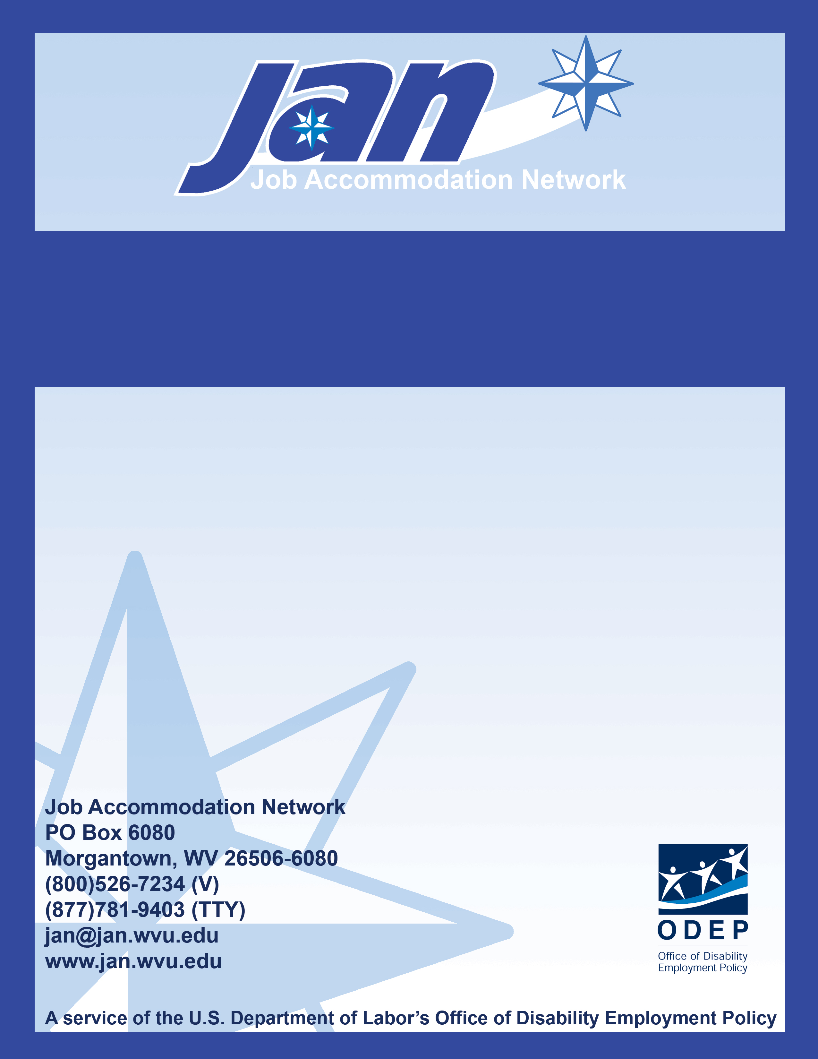
Fact Sheet Series

Pre-Offer, Disability-Related Questions: Dos and Don’ts

JAN’S ACCOMMODATION FACT SHEET SERIES

Pre-Offer, Disability-Related Questions:
Dos and Don’ts

Title I of the Americans with Disabilities Act (ADA) limits an employer's ability to ask disability-related questions or to require medical examinations at three stages of employment: pre-job offer, post-job offer, and during employment. This publication provides information regarding the limitations on disability-related questions at the pre-offer stage. This stage includes job applications and job interviews.

What is a disability-related question?
A disability-related question is a question that is likely to elicit information about a disability. On the other hand, if there are many possible answers to a question and only some of those answers would contain disability-related information, that question is not disability-related.

What questions can employers ask at the pre-offer stage?
In general, employers cannot ask disability-related questions at the pre-offer stage. This means that employers cannot directly ask whether an applicant has a particular disability. It also means that employers cannot ask questions that are closely related to disability.

Why does the ADA prohibit pre-offer disability-related questions?
In the past, some employment applications and interviewers requested information about an applicant's physical and/or mental condition. This information was often used to exclude applicants with disabilities before their ability to perform the job was even evaluated. As a result, Congress established a process within the ADA to isolate an employer's consideration of an applicant's non-medical qualifications from any consideration of the applicant's medical condition.

For additional information, visit Pre-employment Disability-Related Inquiries and Medical Exams (EEOC guidance) at http://www.eeoc.gov/policy/docs/preemp.html.
The following are some examples of permissible and impermissible pre-job offer questions under the ADA:
Job Performance
DO | DON’T
-Are you able to perform the essential function of the job you are seeking, with or without accommodations? | -Do you have any physical or mental impairment that would keep you from performing the job you seek?  -What physical or mental impairments do you have that would affect your job performance?
Attendance Requirements
DO | DON’T
-Can you meet our attendance requirements?  -How many days were you absent from your last job?  -How many Mondays or Fridays were you absent last year on leave other than approved vacation leave? | -How many days were you sick during your last job?
History of Injury
DO | DON’T
-How did you break your leg? | -Do you break bones easily?  -Do you expect the leg to heal normally?
Drug Use
DO | DON’T
-Are you currently using illegal drugs? | -What medications are you currently taking?
-Have you ever used illegal drugs? | -How often did you use illegal drugs in the past?  -Have you ever been addicted to drugs?  -Have you ever been treated for drug addiction?  -Have you ever been treated for drug abuse?
Alcohol Use
DO | DON’T
-Do you drink alcohol?  -Have you ever been arrested for driving under the influence of alcohol? | -How much alcohol do you drink?  -Have you ever participated in an alcohol rehabilitation program?
Updated 8/18/08.

This document was developed by the Job Accommodation Network, funded by a contract agreement from the U.S. Department of Labor, Office of Disability Employment Policy (DOL079RP20426). The opinions expressed herein do not necessarily reflect the position or policy of the U.S. Department of Labor. Nor does mention of trade names, commercial products, or organizations imply endorsement by the U.S. Department of Labor.

